Gift of the Givers Web Application
Student: ST10241408 Phathisa Ndaliso
Module: Applied Programming

Project Overview
The Gift of the Givers Web Application is a humanitarian platform designed to support disaster relief efforts by allowing users to register, report disasters, donate resources, and manage volunteer contributions. The system provides role-based dashboards for Users and Admins, ensuring proper management of donations, volunteers, and disaster incidents.
- GitHub Repository: GiftOfTheGivers-WebApp
- https://github.com/ST10241408/GiftOfTheGivers-WebApp.git
Screenshots of the Web App
Public Pages
- Index Page
- News Page
- About Us Page
- Contact Us Page
- Register Page
- Login Page
- Donate Money Page
Admin Pages
- Admin Home
- Admin Dashboard
- Task Management
- Assign Volunteer

User Pages
- User Dashboard
- Register as Volunteer

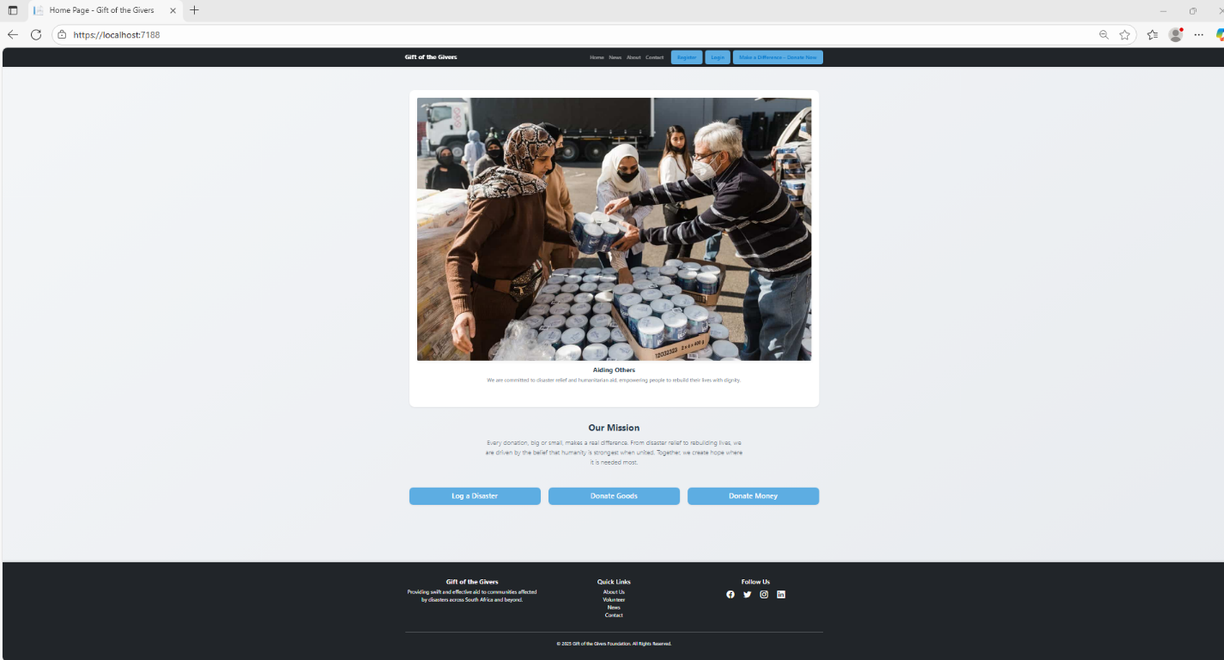
Index page
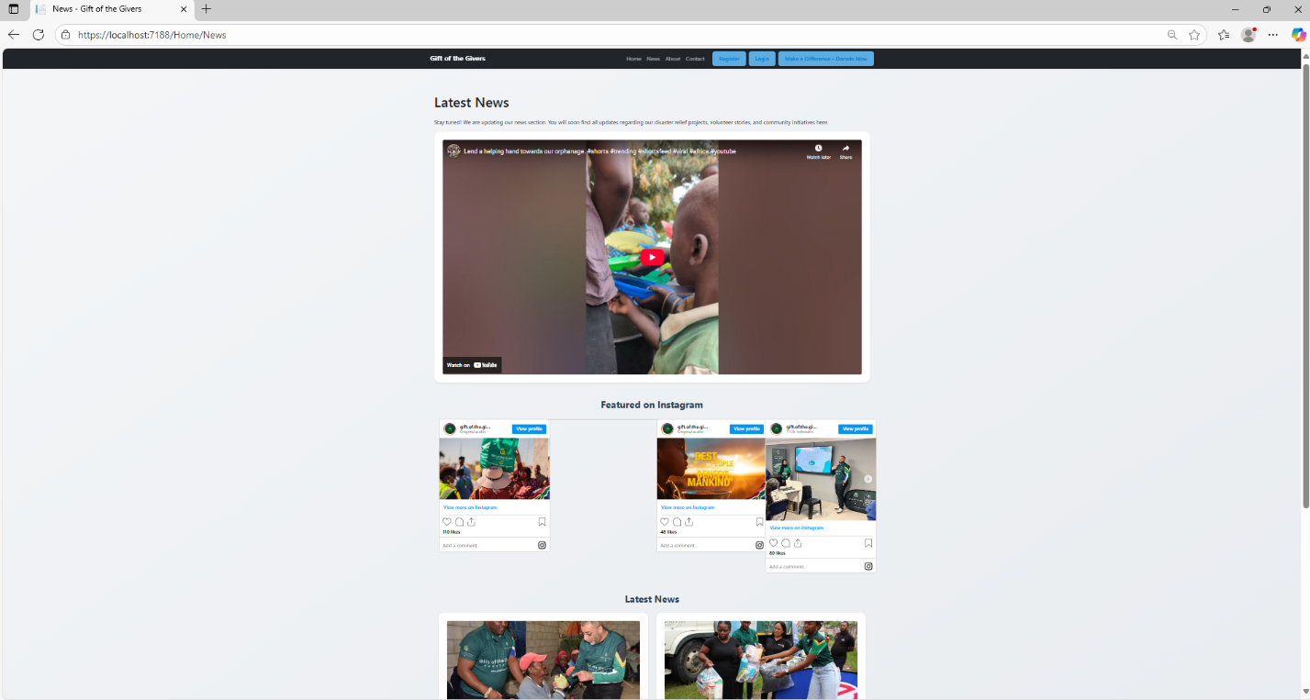
News page
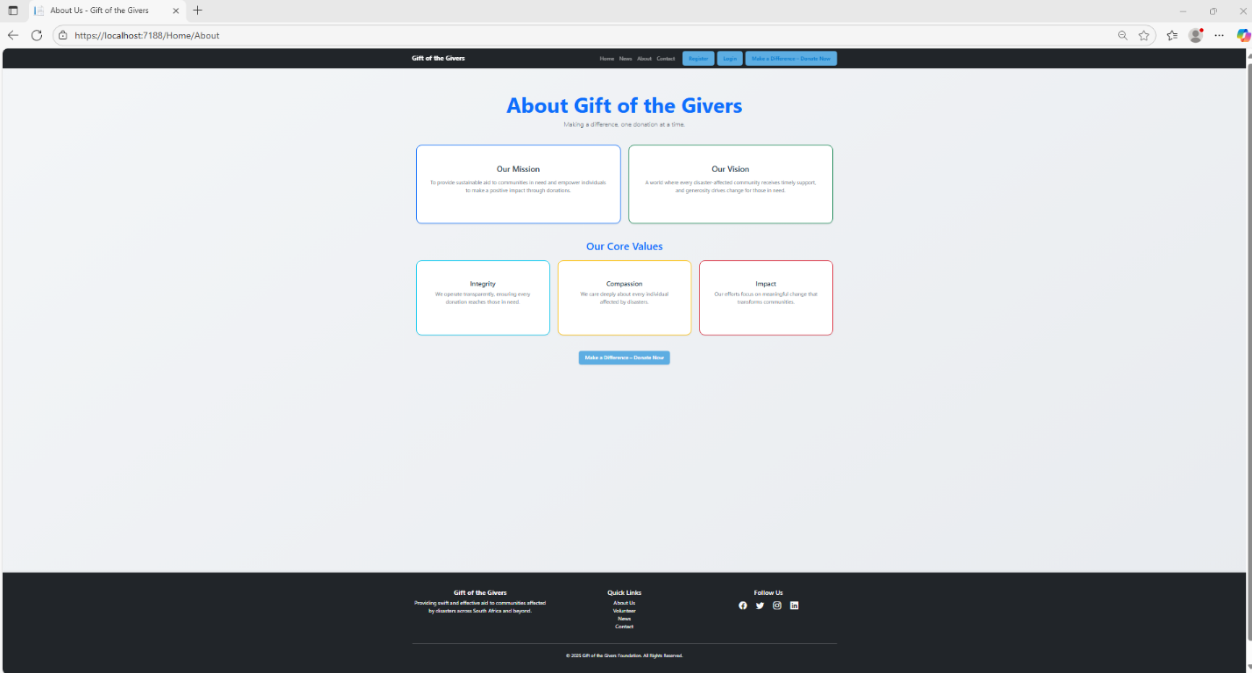
About us page
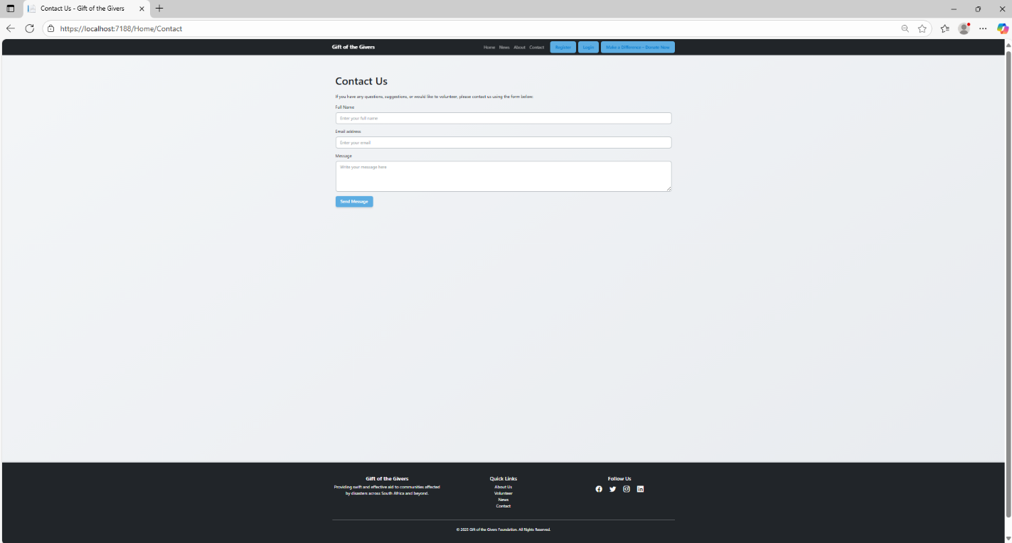
Contact us page
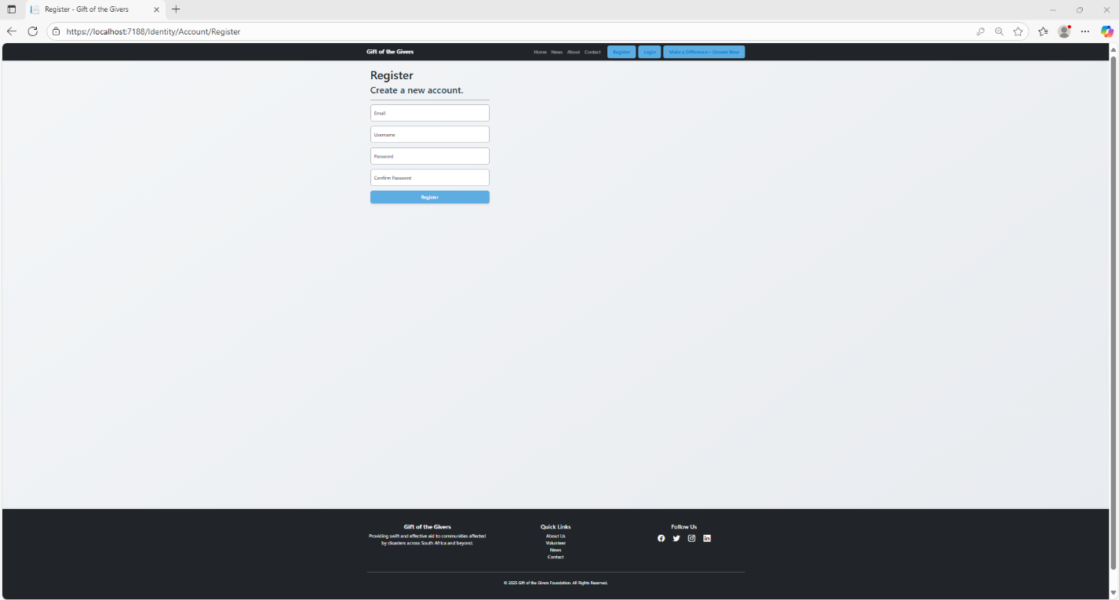
Register page
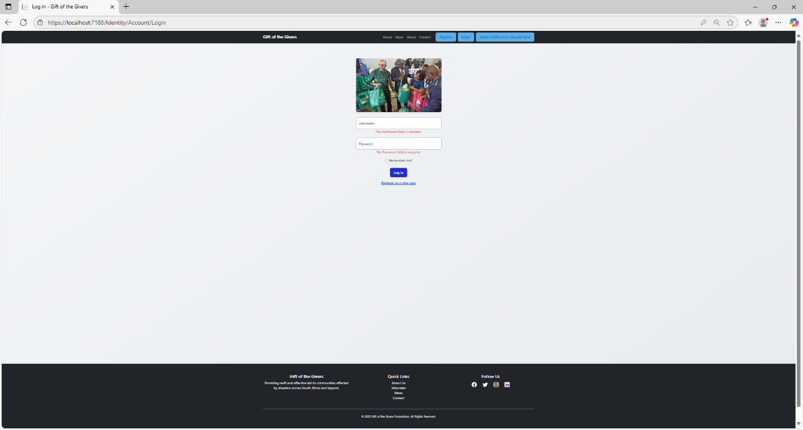
Login page
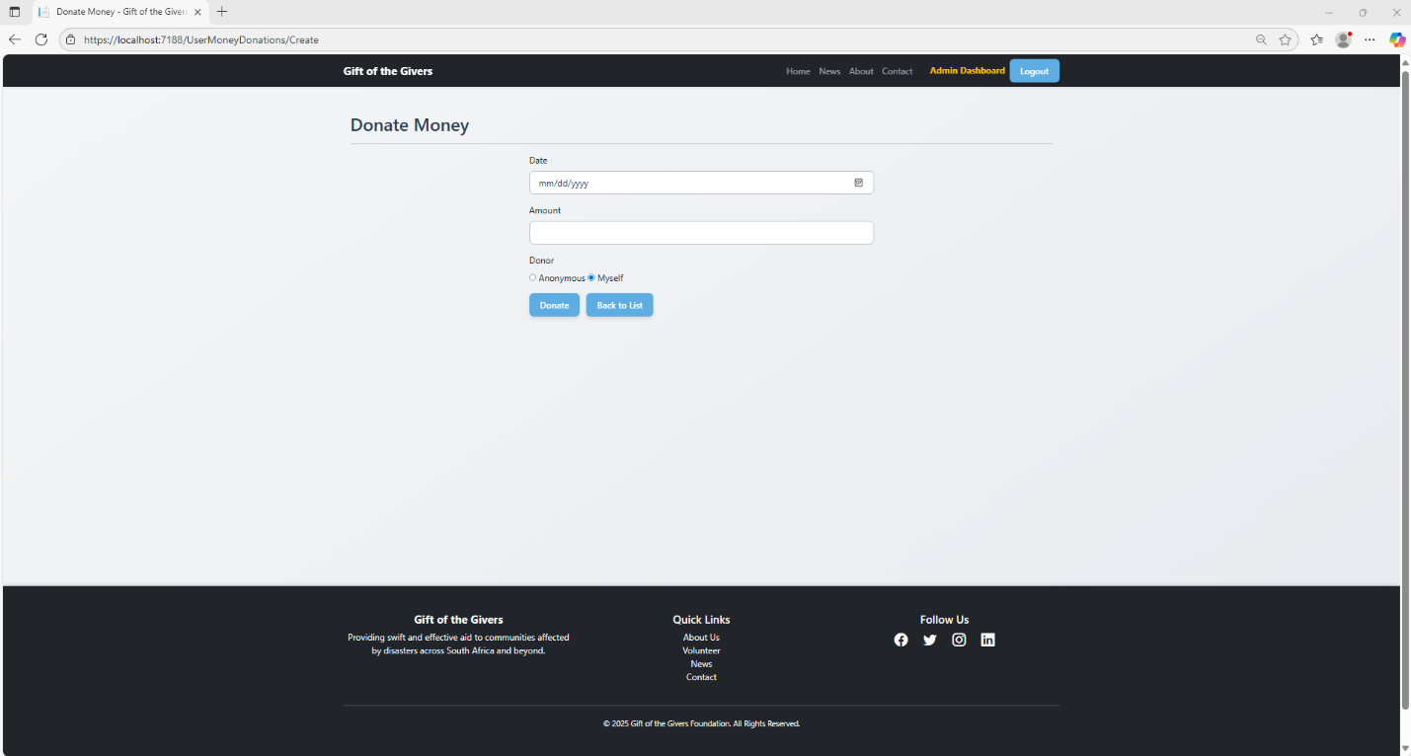
Donate money

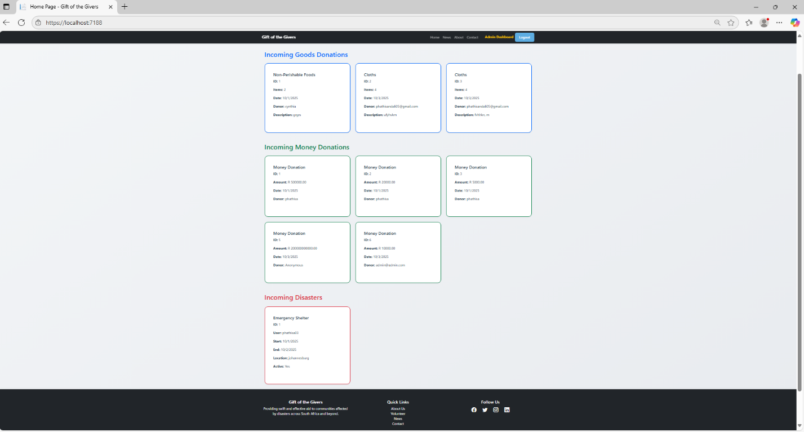
Admin home
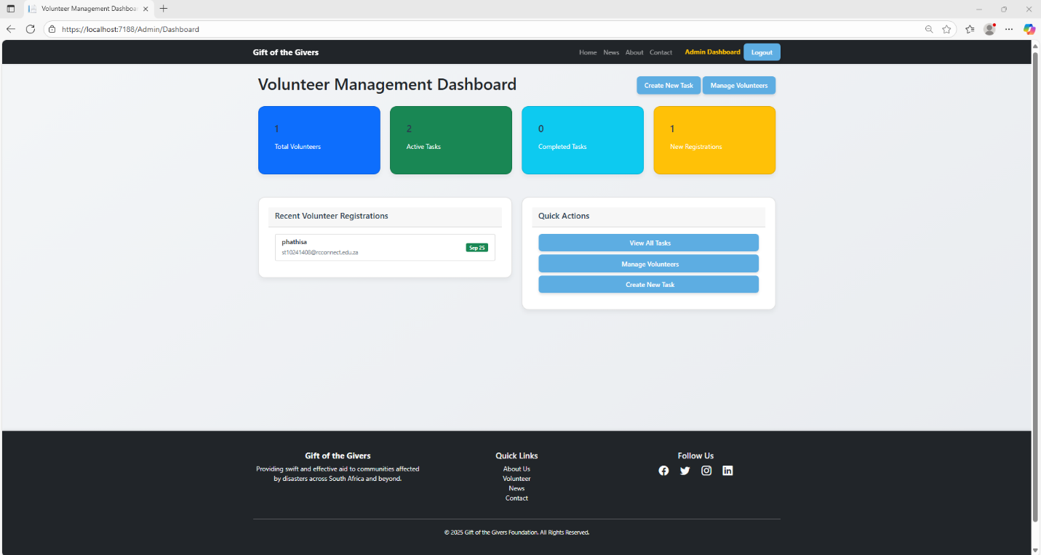
Admin dashboard
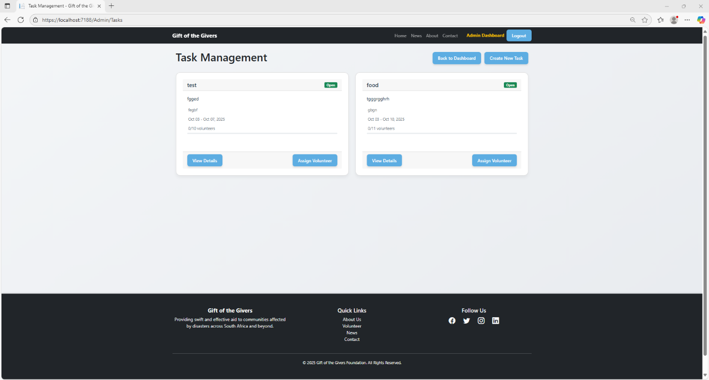
Task management

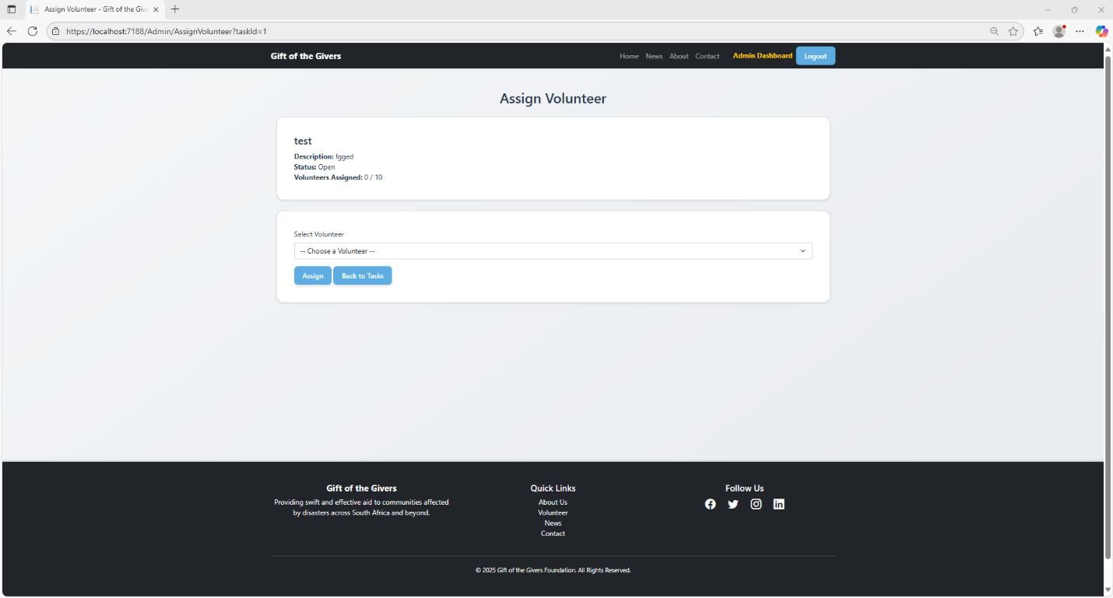
Assign volunteer
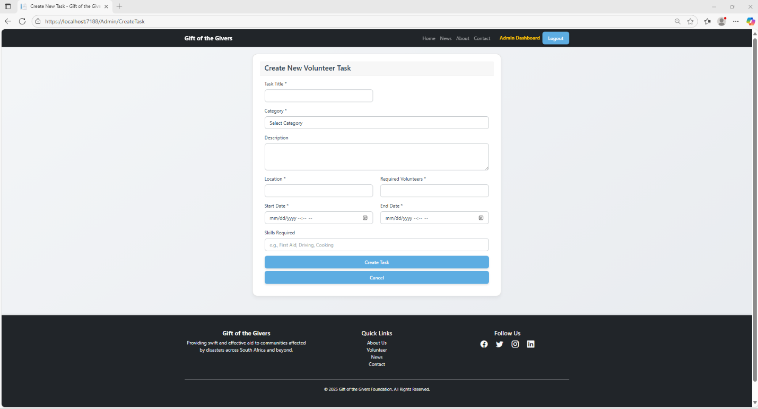
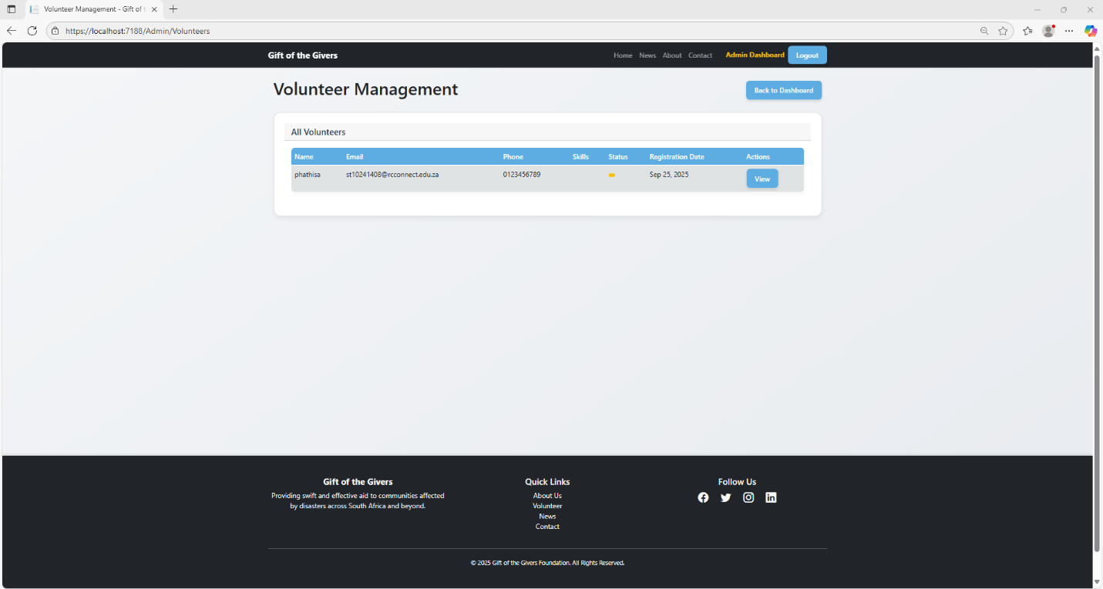
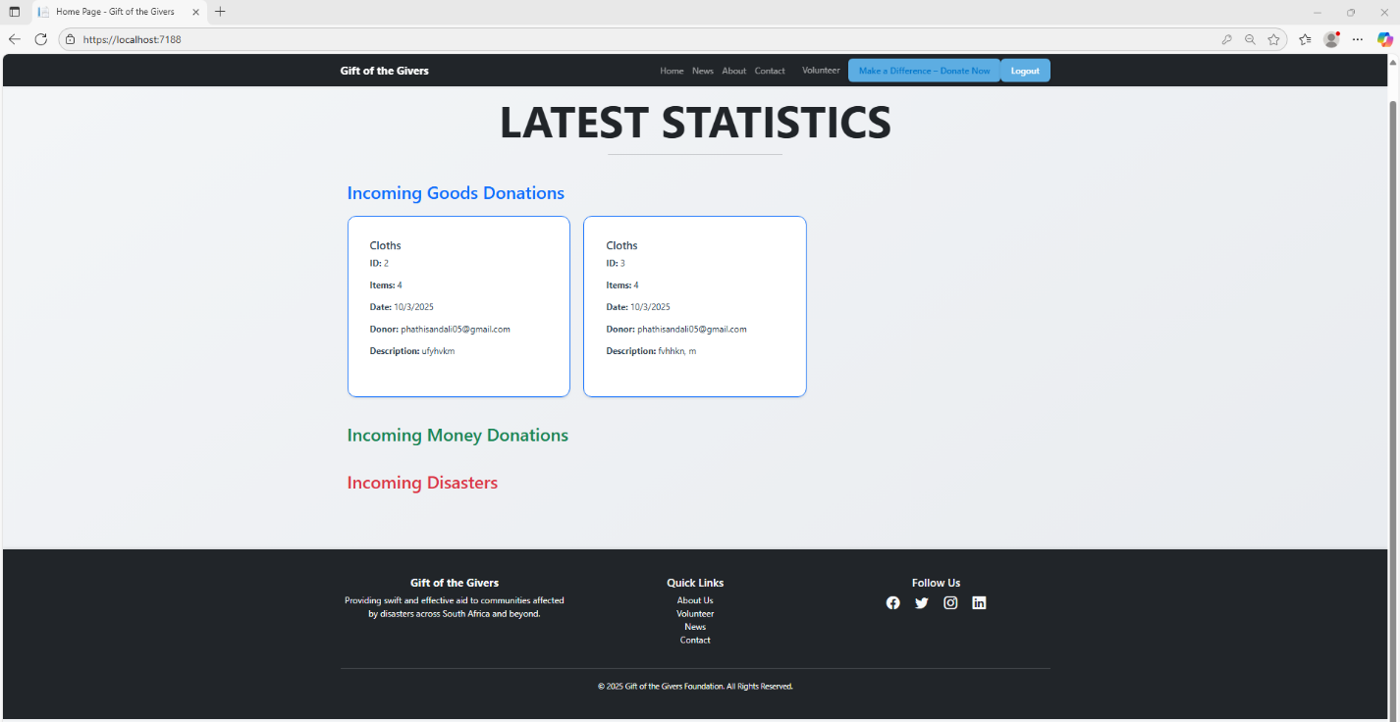
User dashboard
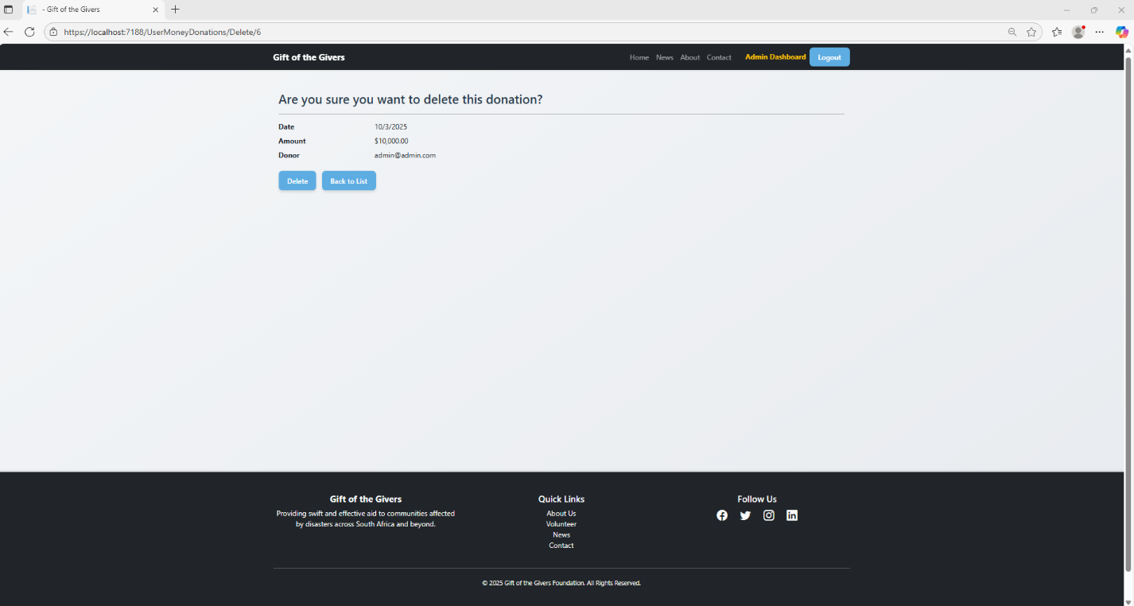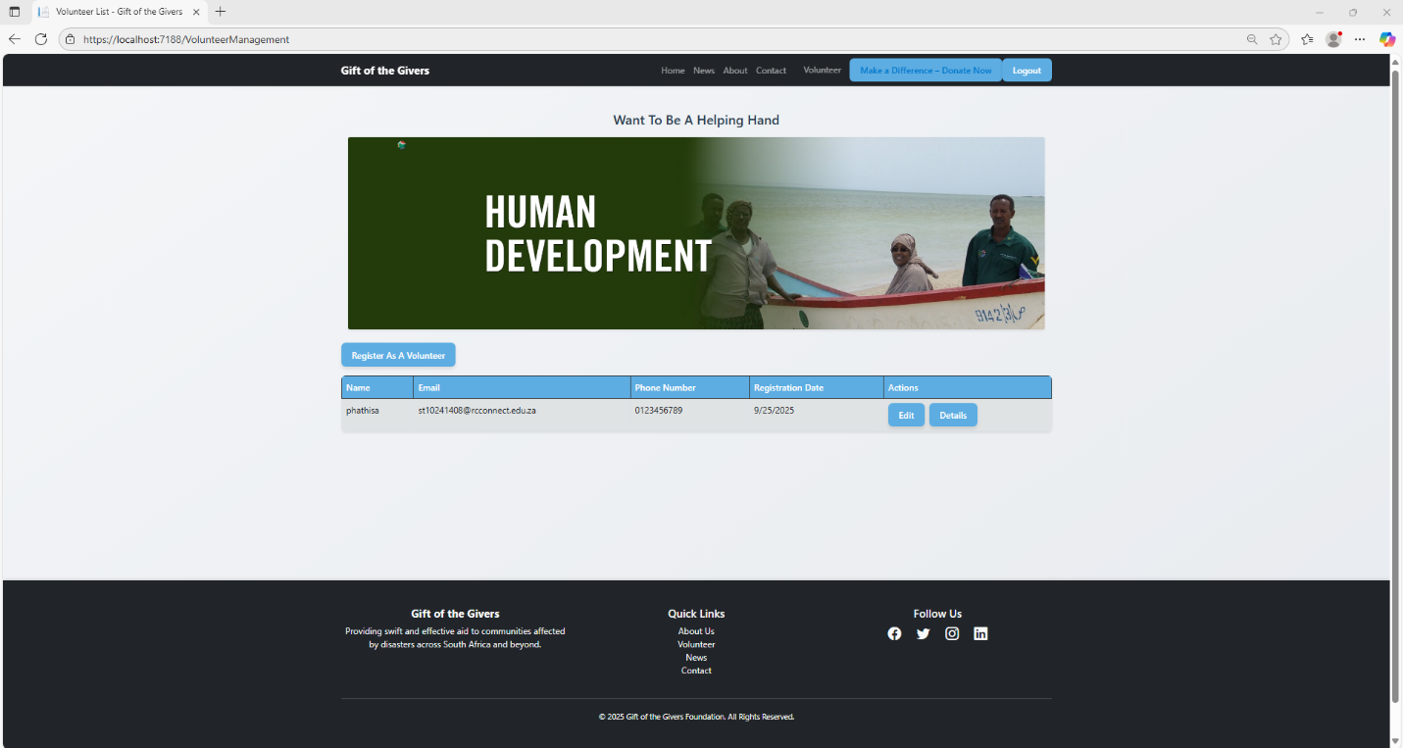

Register as volunteer
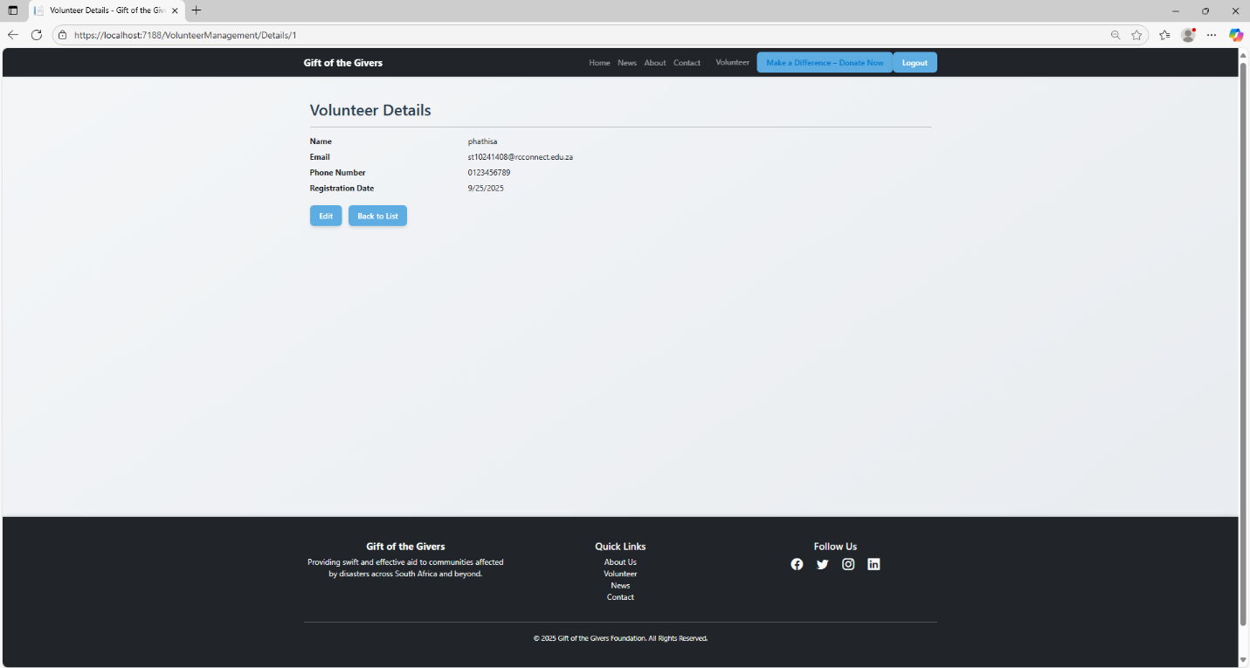
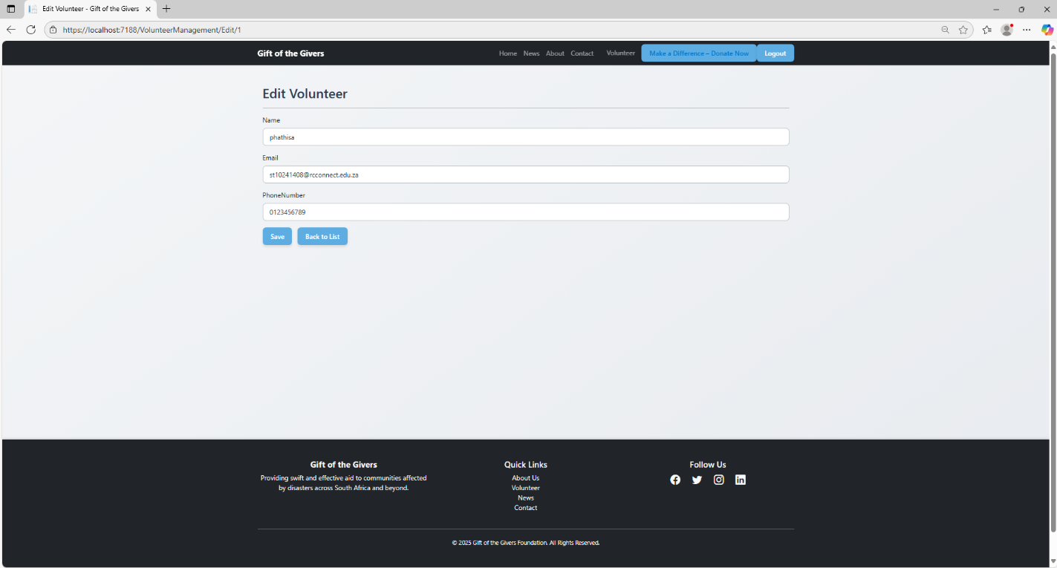
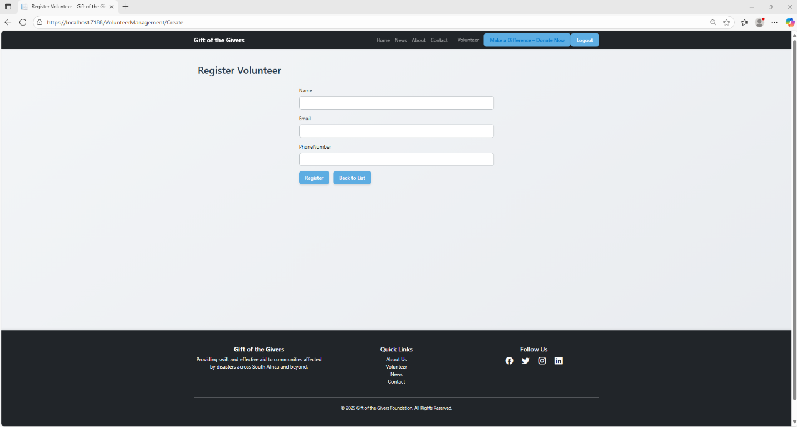
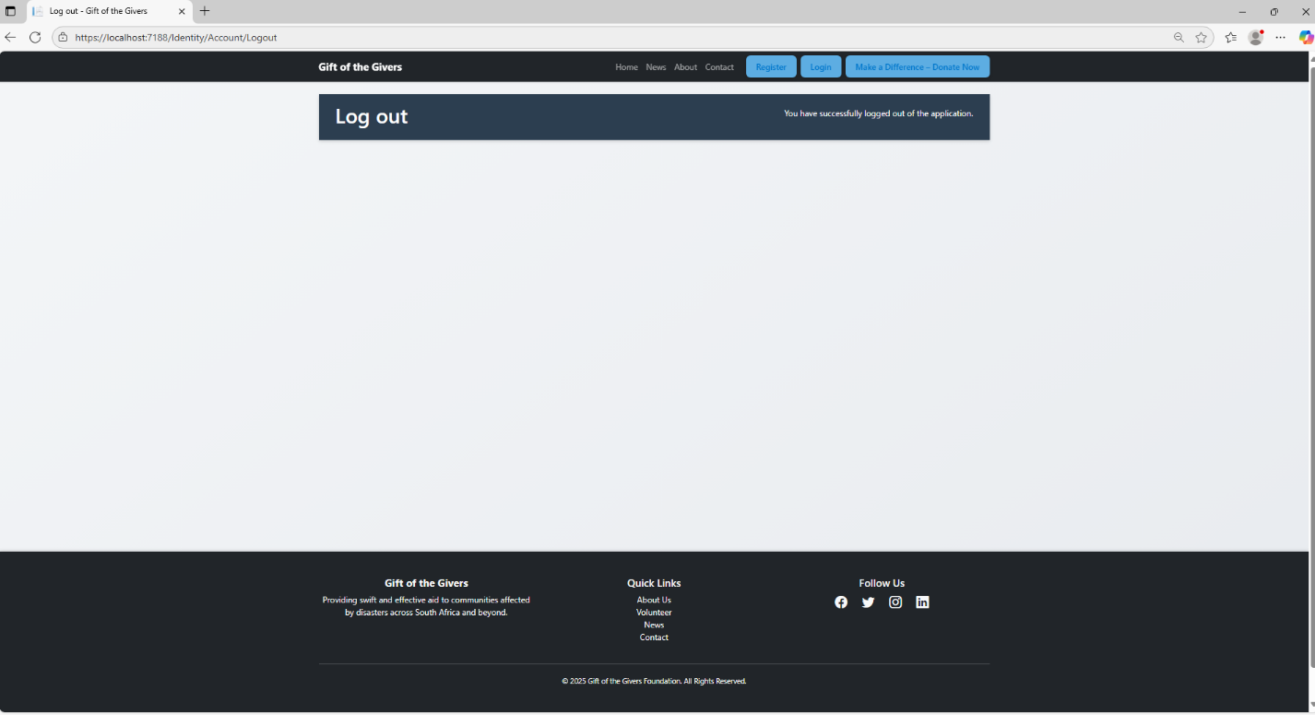
Pipelines
- Azure Pipelines Build Pipeline: Configured for automated build and deployment.
- Tasks Included:
  - Restore NuGet packages
  - Build solution
  - Run tests
  - Publish artifacts
  - Deploy to Azure App Service

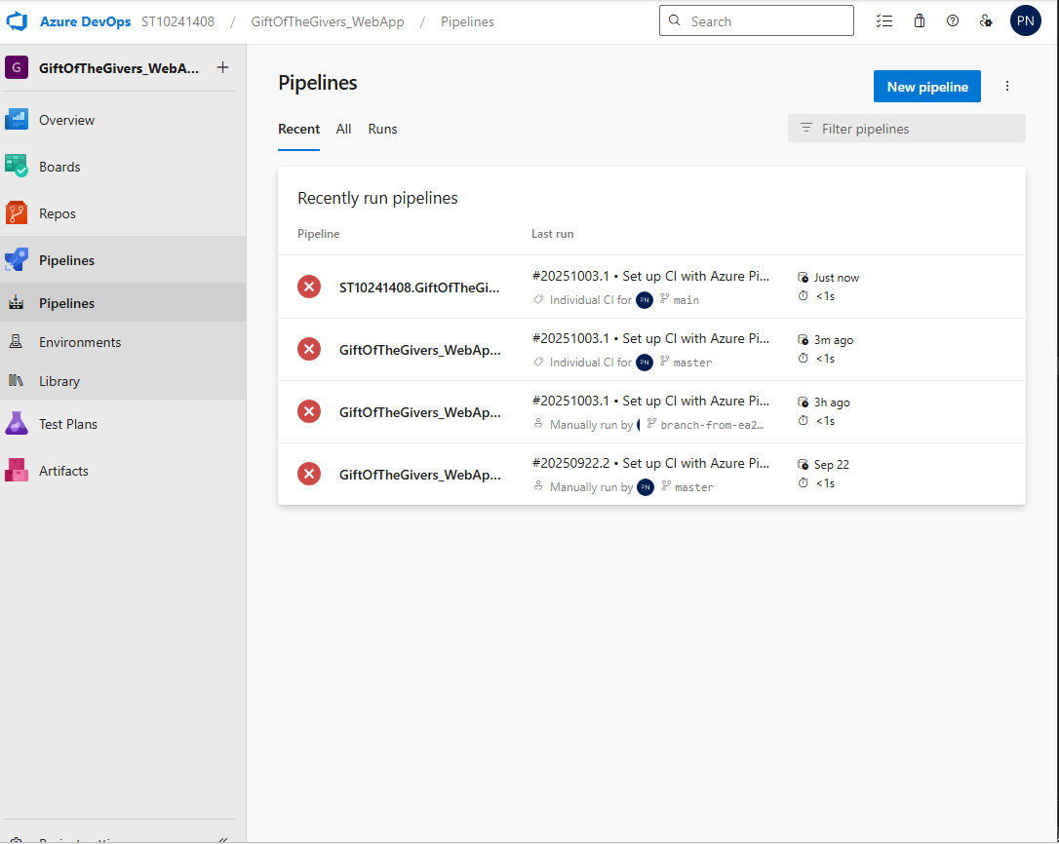

Git Repositories
- GitHub Repository: GiftOfTheGivers-WebApp
- Azure DevOps Repository: Dev Azure

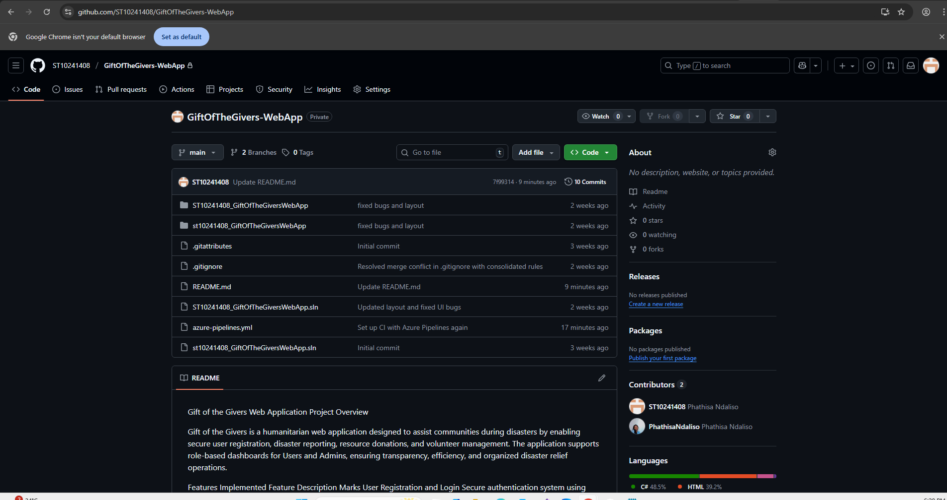

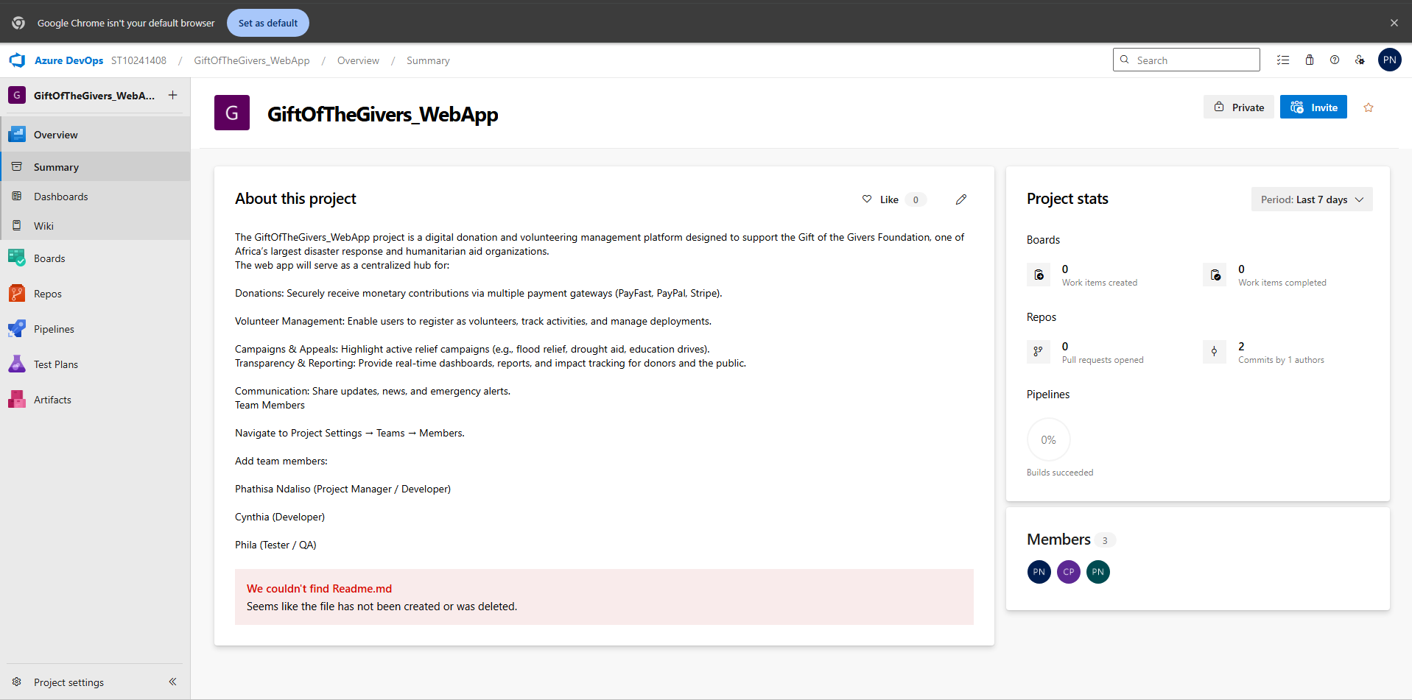

References
- Microsoft Docs – ASP.NET Core MVC
- Microsoft Docs – ASP.NET Identity
- Entity Framework Core – EF Core Documentation
- Bootstrap 5 – Bootstrap Documentation
- Azure DevOps – Pipelines

